Go to <https://atom.io/>

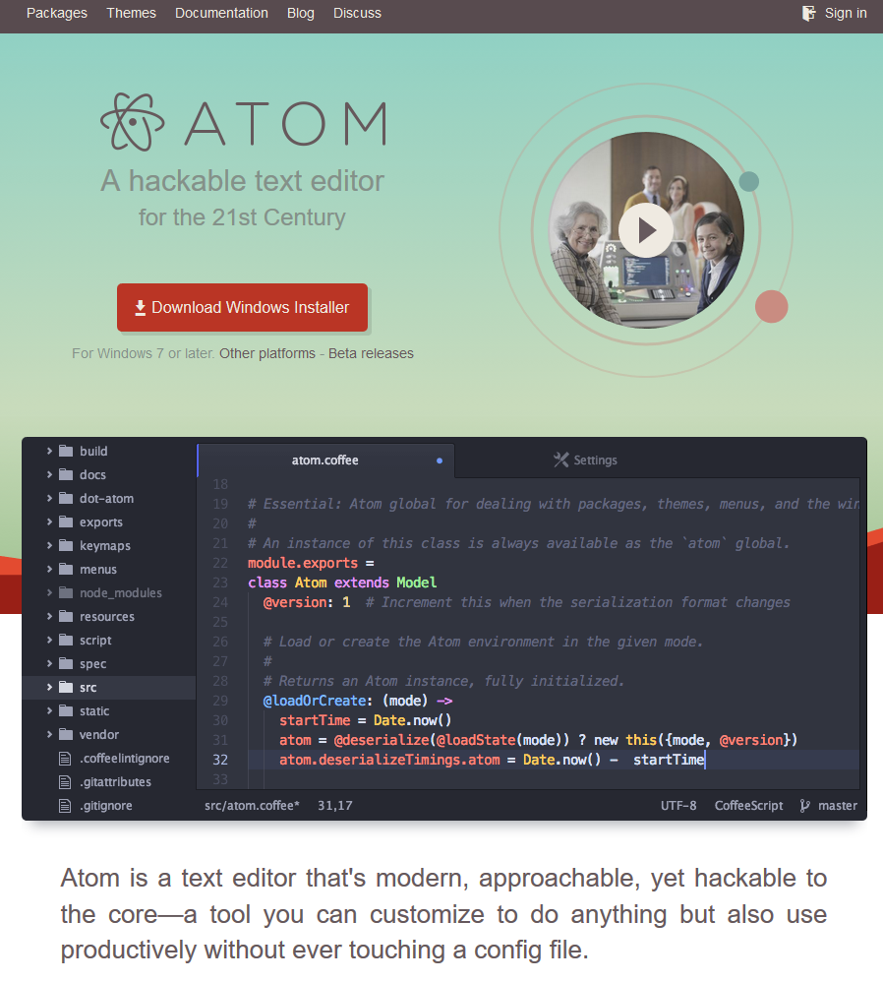

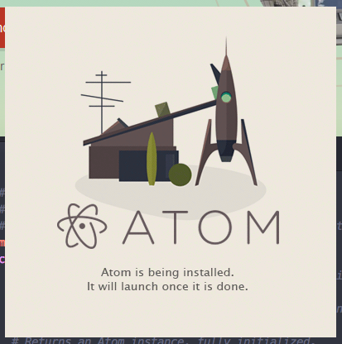

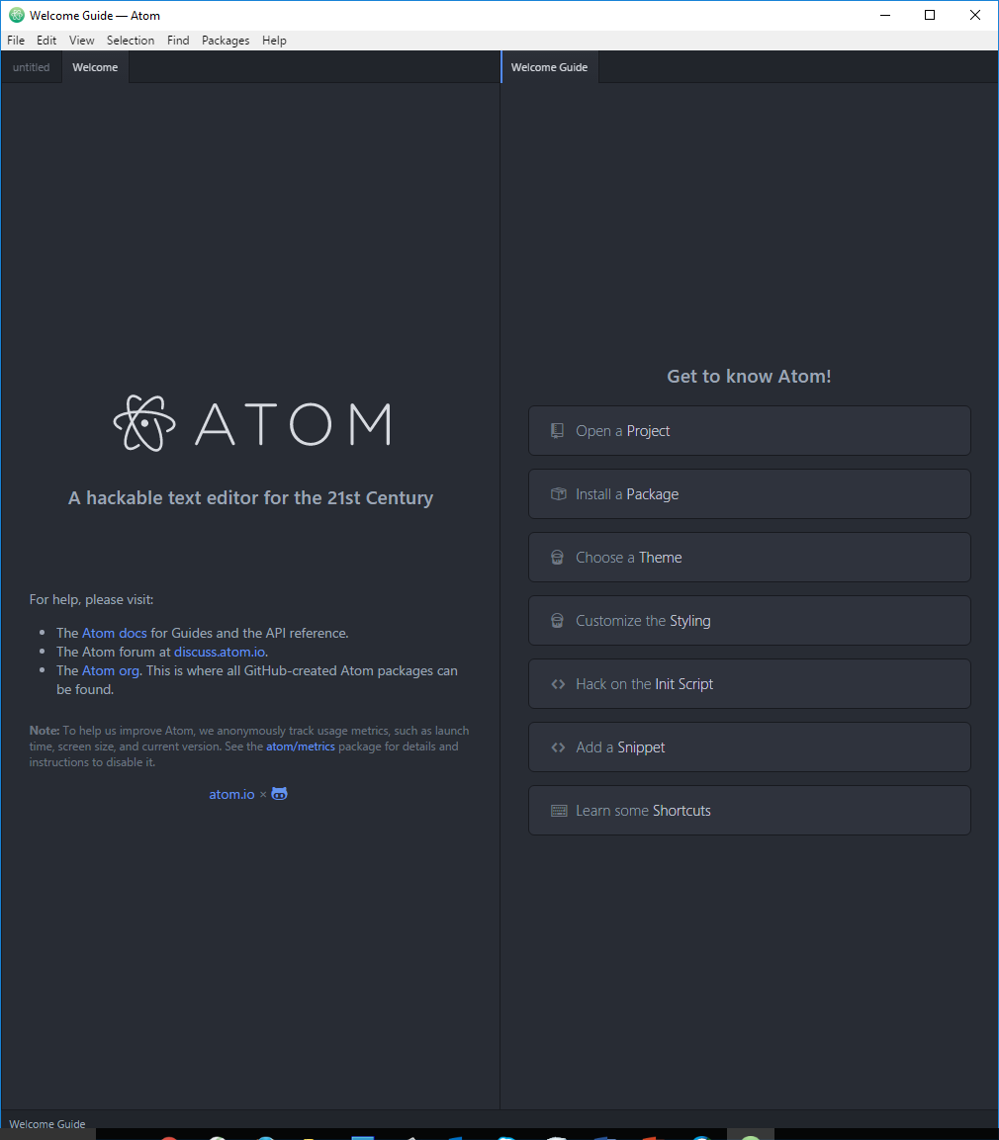

For MAC, go to <https://github.com/atom/atom/releases/tag/v1.8.0>, and search for “atom-mac.zip”.